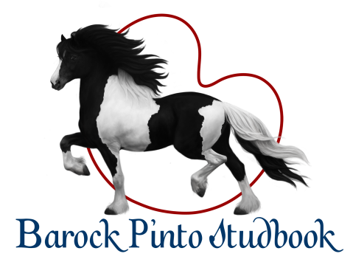
CHANGE OF OWNER

HORSE
Horse Identification Number
Name |  | Mother
Brand Mark or Chip
Studbook Registration
Sex
Date of Birth

PREVIOUS OWNER
Business Name or Company Name
First Name(s) |  |  |  |  |  |  |  |  |  |  | Surname
Personal ID No. |  |  |  |  |  |  |  | / |  |  |  |  |  |  | Company ID No.
Street |  |  |  |  |  |  |  |  |  |  | Building Number |  |  |  |  |  |  |  | Orientation Number
Municipality, Postal Code |  |  |  |  |  |  |  |  |  |  | District / City Part

NEW OWNER
Business Name or Company Name
First Name(s) |  |  |  |  |  |  |  |  |  |  | Surname
Personal ID No. |  |  |  |  |  |  |  | / |  |  |  |  |  |  | Company ID No.
Street |  |  |  |  |  |  |  |  |  |  | Building Number |  |  |  |  |  |  |  | Orientation Number
Municipality, Postal Code |  |  |  |  |  |  |  |  |  |  | District / City Part
Telephone |  |  |  |  |  |  |  |  |  |  | E-mail
* To request a change of owner in the studbook, it is mandatory to attach the laminated horse pedigree certificate
* The change of owner in the passport is processed by the Central Horse Register Czech Republic, Slatiňany

Change completed on: . .

Signature and/or stamp: ………………………………………….  Signature of the previous owner | Signature and/or stamp: ……………………………………….  Signature of the new owner

